# Internship Studio

Ethical Hacking

**Training + Internship**

**TASK1: -** To solve any 5 XSS labs from

<https://portswigger.net/web-security/all-labs>.

**Lab1: - Reflected XSS into HTML context with nothing encoded**

This lab contains a simple Reflected cross-site scripting Vulnerability. We can find this vulnerability in search functionality.

Procedure:

1. Click on access the lab tab
2. In search box type a cross-site script as <script>alert(1)</script>
3. Enter.

Cross-site script use in search box is:

<script>alert(1)</script>

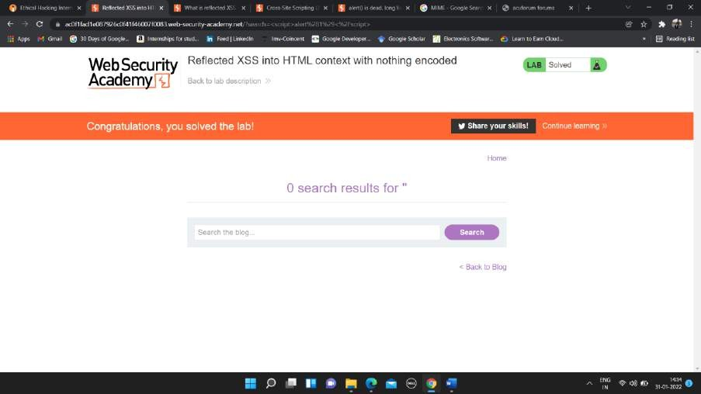

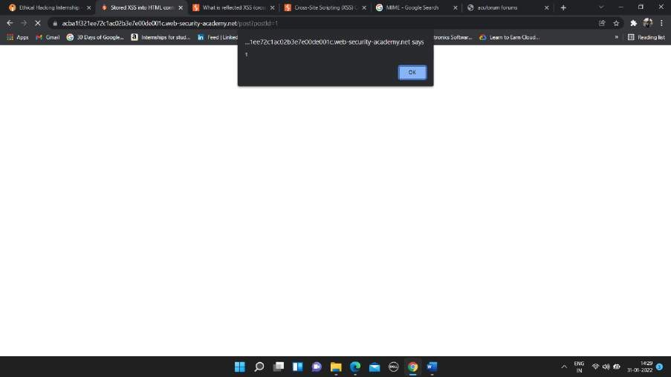



Lab_ Reflected XSS into HTML context with nothing encoded _ Web Security Academy - Google Chrome 2022-02-01 12-58-12.mp4

**Lab2: - Stored XSS into HTML context with nothing encoded**

### This lab contains the stored cross-site scripting vulnerability. To find this vulnerability we need to write a cross-site script in comment with name, email-id and website name.

In comment box write below script

Cross-site script use: <script>alert(1)</script>

Procedure:

1. Click on tab access the lab.
2. Go to any one of the posts and scroll down to end of the page.
3. Here we want to enter the script in comment box as

<script>alert(1)</script>

1. Enter the name, email-id, and website name.
2. Click on Post Comment.
3. Go back to blog.

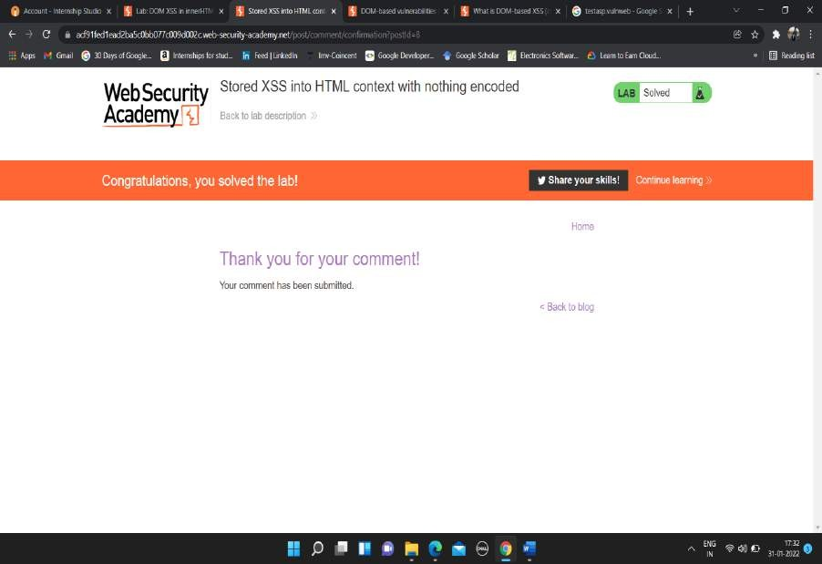

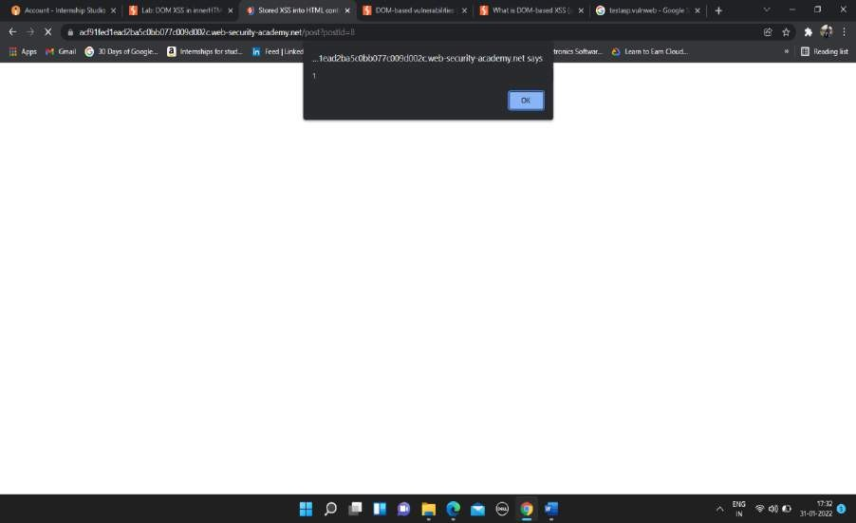



Lab_ Stored XSS into HTML context with nothing encoded _ Web Security Academy - Google Chrome 2022-02-01 13-17-06.mp4

**Lab3: - DOM XSS in document.write sink using source location.search**

This lab contains the DOM based cross-script scripting vulnerability in search of query tracking vulnerability. Here I use JavaScript document.write function, which write data out of page. Here in search box the cross-site script is written to find the vulnerability.

Write below cross-site script in search box

“><svg onload = alert(1)>

Procedure: -

1. Click on access the lab tab.
2. In search box type cross-site script as “><svg onload=alert(1)>
3. Click Enter.

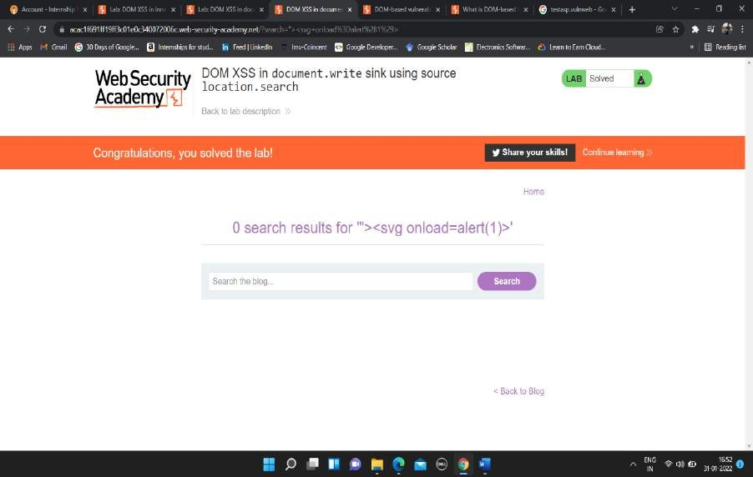

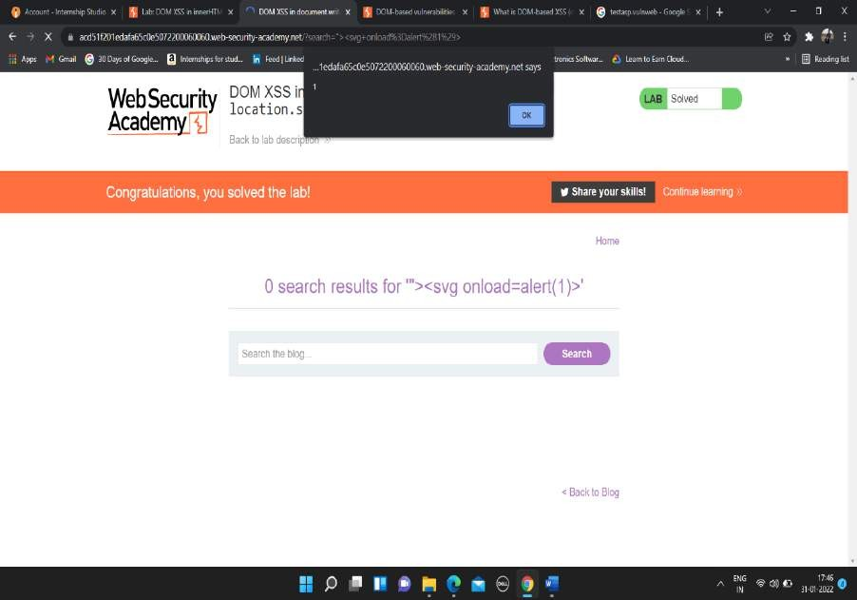



Lab_ DOM XSS in document.write sink using source location.search _ Web Security Academy - Google Chrome 2022-02-01 13-22-59.mp4

## Lab4: - DOM XSS in innerHTML sink using source location.search

This lab contains the DOM based cross-site scripting vulnerability in the search box functionality. It uses an innerHTML assignment, which changes the HTML contents of a div element, using data from location.search.

Cross-site script use in search box is

<img src onerror=alert(1)>

Procedure: -

1. Click on tab access the lab
2. In search box type <img src onerror=alert(1)> a cross-site script
3. Enter.

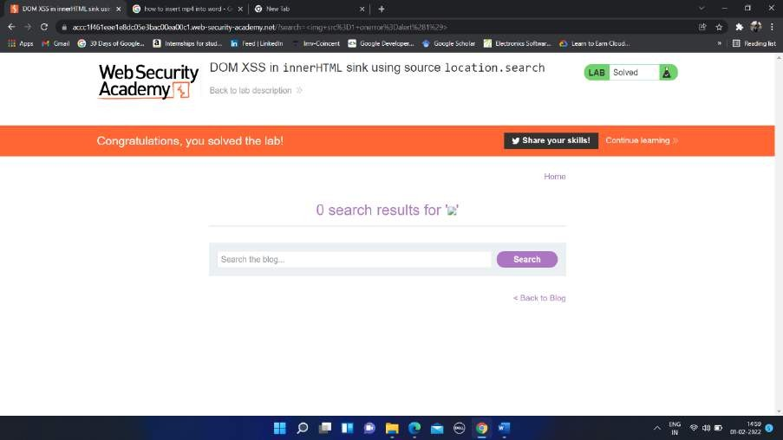

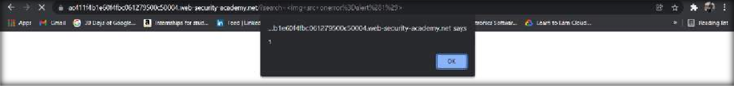

Lab_ DOM XSS in innerHTML sink using source location.search _ Web Security Academy - Google Chrome 2022-02-01 14-58-22.mp4

## Lab5: - DOM XSS in jQuery anchor href attribute using location.search source

This lab contains a [DOM-based cross-site scripting](https://portswigger.net/web-security/cross-site-scripting/dom-based) vulnerability in the submit feedback page. It uses the jQuery library's $ selector function to find an anchor element, and changes its href attribute using data from location.search.

Procedure: -

1. Click on access the lab tab.
2. Click on Submit feedback icon.
3. You will next page with URL as https://ac671fae1fec9f86c0634336007900ee.web-security- academy.net/feedback?returnPath=/
4. Here cross-site scripting is done in url of the lab
5. Click on URLs and after the returnPath= type javascript:alert(1). Final URL will be https://ac671fae1fec9f86c0634336007900ee.web-security- academy.net/feedback?returnPath=javascript:alert(1)
6. Press Enter.

Cross-site script use in url is

javascript:alert(1)

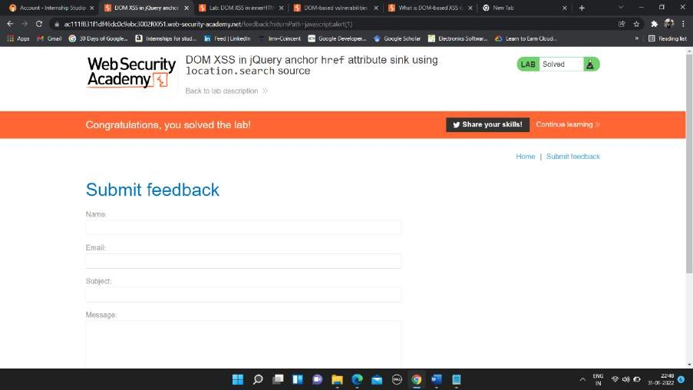

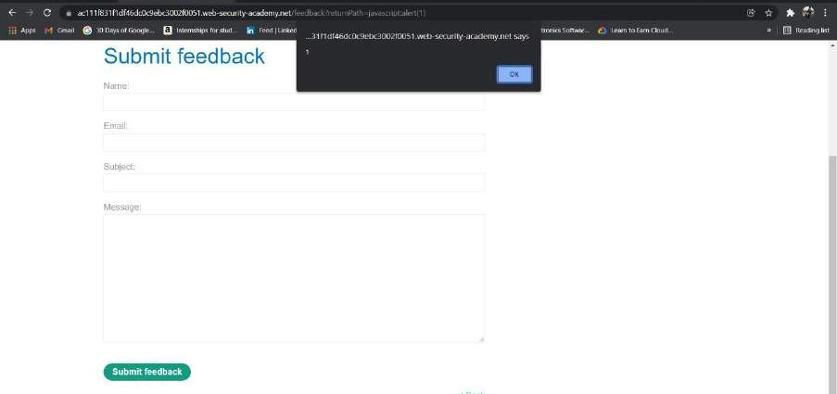



Lab_ DOM XSS in jQuery anchor href attribute sink using location.search source _ Web Security Academy - Google Chrome 2022-02-01 15-03-35.mp4